Marketing
campaign
playbook

Lorem ipsum dolor sit amet, consectetur.

Name/Date

Purpose of the playbook
This playbook defines the required process for how Campaign Managers and the broader team work together to plan, create, review, publish and track all marketing campaigns.
The goal of this playbook is to:
- Create consistency across campaigns
- Set clear expectations and ownership
- Enable better planning and capacity management for the team
- Reduce rework and last-minute requests
- Provide better visibility into campaign progress and performance
This process applies to all campaigns.

What is a campaign?
A campaign is a strategically aligned, cross-functional marketing initiative designed to drive measurable business outcomes within a defined audience and timeframe. It is built around a clear market opportunity, aligned to an identified ICP and anchored in differentiated messaging. The Redwood messaging architecture is a reference for campaigns.
Campaigns include:
- use cases or sub-use cases, such as payment modernizations within the WLA tool modernizations use case
- campaign themes running on a period basis, such as false confidence in the close, within the touchless close theme
- expansion campaigns - part of Redwood messaging architecture
- product launches
- event sponsorships and engagements
- third-party analyst research and recognition programs, such as Gartner Magic Quadrant and SAP awards
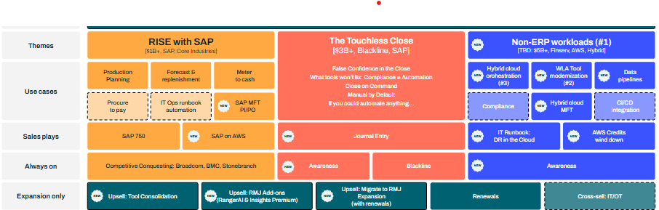
- brand campaigns

When should a campaign start?
The start of a campaign depends on the campaign type and typically begins with messaging and positioning after a need or opportunity has been identified.
Every campaign with external-facing promotion should have a kickoff meeting with the working team, taking place on average 8 weeks before the campaign goes live. A kickoff meeting requires finalized messaging and the campaign deck.

Common timeline
1-2 months – messaging and positioning
Milestone – kickoff
2 months content and design
2 weeks of sales enablement
2 weeks of promotional and reporting setup
Milestone – Live

Product launch tiers and kickoff timelines
Tier and description | Kickoff before live
Tier 1: New portfolio solution or portfolio level change, new market, innovation, unique competitive differentiator | 8 weeks
Tier 2: New major capability or overhaul of capability for a product, pricing and packaging changes, new revenue streams, notable company recognitions | 6 weeks
Tier 3: New feature, core releases, moderate product changes | No kickoff - no external materials
Tier 4: Hotfix, bug or security fix | No kickoff - no external materials

Contents

Purpose of the playbook 2
What is a campaign? 2
When should a campaign start? 3
Common timeline 3
Product launch tiers and kickoff timelines 3
Contents 4
Campaign Managers 7
Supporting team members 8
Campaign RACI 9
Responsible 9
All — These expectations apply to all Marketing team members, regardless of role or reporting structure: 9
Content and Creative 10
Customer Marketing 10
Paid 10
Partner/Alliances 10
Product Marketing 11
PR / AR 11
Reporting / MarOps 11
SEO/GEO 11
Social 12
Web 12
Accountable 12
Campaign Manager 12
Contributing 13
Informed 13
Phase 1: Campaign kickoff - setup and prep 13
Campaign name 14
Campaign folder on Shared Google Drive 14
Campaign setup in Asana 15
Campaign theme portfolio 16
Campaign portfolio creation 16
Projects 17
How to set up a project template 17
Portfolio structure 18
Working team established 18
Research 19
Market 19
Subject matter experts (SMEs) 19
Redwood customers 19
Analysts 20
🏁Messaging and positioning 20
Slack channel 21
Keyword research and assets 21
Scheduling and materials for kickoff 22
Turnaround time by deliverable for planning 23
🏁Campaign kickoff meeting 24
Kickoff expectations 25
Phase 2: Campaign development (post-kickoff) 25
Adding deliverables to Asana 25
Adding folders to the Google folder 28
Reporting 29
Channel performance 30
Web 30
Email 30
Paid media (search, social, display) 30
Organic social 30
PR 30
Funnel impact 30
Product adoption - applicable to product launches 31
Communications and channels 31
Status updates 31
Feedback and approvals during asset creation 32
Meeting cadence 32
Resources 33
Asana learning path 33
Redwood Asana tutorial videos 33

Campaign Managers
Campaign Managers hold the ownership and accountability for delivering successful campaign launches and outcomes.

Campaign Manager | Primary focus
Abi Downs | Events - SOAP
Allison Zerger | New logo - SOAP
Burke Fewel | SAP S2S
Autumn Wilson | Events - Finance Automation
Simon Shah | Finance Automation
Alexandra Turnquist | Expansion - NA SAM
Danielle Ybarra | Customer marketing - retention
Dan Pitman | Product releases - SOAP
Kristin Gelinas | Product releases - MFT
Chandler Johnson | Expansion - Global CAM
Megan Holgate | Expansion - EMEA SAM
Rebecca Overton-Polk | New logo and expansion - Cerberus

Supporting team members
Campaign success relies on a cross-functional marketing team, with each function responsible for executing its defined role within the broader strategy.
Product Marketer | Primary focus
Tim Eusterman | Messaging and positioning - SOAP
Neil Krefsky | Messaging and positioning - SAP
Kristin Gelinas | Messaging and positioning - MFT
Dan Pitman | Product launches and releases - RunMyJobs

Creative and Comms | Primary focus
Chelsea Williams | Content - SOAP and SAP
MyLynda Stubblefield | Content - Emerging business (FA + MFT)
Mark Burbery | Design and video
Ashvin Gadda | Design
Noah Walton | Design
Stephani Fitzsimmons | AR and PR
Keeley OConnor | Social

Organic and Paid | Primary focus
Kasia Jezuit | SEO and GEO
Sofya Perrin | SEO and GEO
Tracy Smith | Web management
Happy Lee | Paid - SOAP
Ashton Clarke | Paid - Emerging businesses (FA + MFT)

Campaign RACI
The Campaign Manager is accountable for the overall success of a campaign, from initial planning and execution through launch and performance measurement.
Campaign leadership is role-based, not title-based. Depending on the campaign type, certain teams may serve as the Campaign Manager in one instance and as supporting contributors in another.
For example:
- Customer Marketing may act as the Campaign Manager for expansion campaigns, while serving as a supporting partner for product release campaigns
- Content may lead a research report campaign as the Campaign Manager, but contribute in a supporting role within a broader themed marketing campaign
- Product Marketing may own product launches as the Campaign Manager and be responsible for positioning and messaging, supporting marketing campaigns

Responsible

All — These expectations apply to all Marketing team members, regardless of role or reporting structure:
- Follow the guidelines outlined in this playbook when planning, executing and delivering campaign work
- Setup your designated Asana projects and use Asana daily to stay informed on current and upcoming task and subtask due dates
- Meet assigned due dates, and proactively communicate before a deadline is at risk. If a task or subtask is off track, notify relevant stakeholders early and propose a revised timeline or solution. If a due date for a task needs to be changed, ensure that all dependent task due dates are updated accordingly.
- Maintain consistent file and sharing structures across Google Drive and Asana, including:
- Proper folder placement
- Standardized asset naming conventions
- Clear version control
- Consistent naming in communications and presentations

Content and Creative
Content and creative execution
- Creating assets from the approved BOM
- Managing writing, editing and design workflows
- Ensuring brand, quality and editorial standards
- Managing press releases and PR coordination
- Managing analyst communications
Project execution
- Using approved Asana templates
- Providing status updates in Asana
- Communicating blockers or timeline risks
- Enforcing intake requirements and review timelines
Publishing coordination
- Coordinating publishing with Web, Social and Paid

Customer Marketing
- Developing case studies
- Supporting advocacy initiatives
- Coordinating newsletter inclusions
- Supporting retention or expansion messaging

Paid
- Developing paid media plan aligned to campaign objectives
- Creating and launching ad campaigns
- Managing budget and channel performance
- Providing reporting on paid performance metrics

Partner/Alliances
- Share press releases, product announcements, case studies and reports with relevant partners
- Enable partners with approved messaging, social copy and graphics
- Coordinate co-promotion (email, social, blog, newsletters, partner portals), identifying which partners should amplify and at what level
- Pursue opportunities for sales calls, joint webinars, events, marketplace promotions and partner blogs, newsletters or community forums

Product Marketing
Pre-kickoff
- Conducting research (market, ICP, competitors, SMEs, analysts)
- Developing and finalizing messaging and positioning
- Creating messaging document and kickoff-ready materials
- Reviewing and editing AI-generated messaging
Development
- Reviewing thought leadership content
- Providing product-level accuracy and technical validation
- Delivering sales enablement materials (deck, slides, demo assets, connector pages)
Ongoing
- Ensuring messaging consistency across assets

PR / AR
- Managing analyst engagement strategy
- Drafting press materials
- Coordinating external media outreach
- Aligning recognition programs (Gartner, SAP awards, etc.)

Reporting / MarOps
- Implementing tracking links and campaign attribution
- Ensuring assets are trackable before launch
- Building dashboards for leading and lagging indicators
- Providing campaign performance reports

SEO/GEO
Pre-kickoff / early development
- Conducting keyword research once messaging is complete
- Delivering SEO recommendations for:
  - Solution pages
  - Blogs and articles
  - Refreshes
- Documenting findings in Drive
- Setting up appropriate Asana projects
Ongoing
- Ensuring search optimization is reflected in final copy
- Monitoring organic performance

Social
- Building a social plan aligned to campaign objectives
- Drafting and scheduling posts
- Coordinating amplification of key assets
- Monitoring engagement metrics
- Providing reporting on social performance metrics

Web
- Setting up campaign-related webpage projects (net new and Setting up web projects in Asana
- Creating staging links
- Publishing pages, blogs and landing pages
- Implementing SEO recommendations
- Ensuring technical QA prior to publishing
- Maintaining publish dates in alignment with launch timeline

Accountable

Campaign Manager
Strategy and planning
- Campaign scope, objectives and KPIs
- Timeline and launch readiness
- Maintaining campaign portfolio in Asana
- Ensuring messaging is finalized before kickoff
Execution oversight
- Hosting kickoff
- Providing complete BOM with owners and due dates
- Ensuring assets are added to Asana within 48 hours
- Ensuring custom fields are completed correctly
- Ensuring reviews and approvals are completed on time
Launch and performance
- Confirming all assets are launch-ready
- Submitting all asset links to MarOps for tracking
- Monitoring performance against defined KPIs
- Leading post-mortem

Contributing
- Product: CPO, Product Managers, CTOs
- Sales: AEs, Solution Engineers
- External SMEs
- Customers
- Analysts

Informed
- Sales
- Account Managers
- Customer Success
- Alliances
- Organization

Phase 1: Campaign kickoff - setup and prep
Asana project template: Pre-kickoff setup ⚙️

Campaign name
Owner: Campaign Manager
Marketing campaigns should have an established name used across the team, in most cases mirroring what’s provided in the campaign breakdown within the messaging architecture. Product releases should use version numbers. The campaign name should match across Google Drive, Asana and Slack channels.

Campaign folder on Shared Google Drive
Owner: Campaign Manager
The campaign needs to have a dedicated folder on the shared drive, accessible across Marketing. All campaign files should be kept here. You can use shortcuts to connect with any other filing system, such as within your function.
Campaign research, messaging and the campaign kickoff deck should be housed here and available before kickoff.
A folder should be created in this drive for each deliverable, matching the projects in Asana. Examples include blogs, web pages, ads, press releases, etc.

Campaign Google Drive folder structure 📁
Marketing INTERNAL
└──> 00.Campaigns
└──> [Campaign theme]
└─-> [Campaign name]

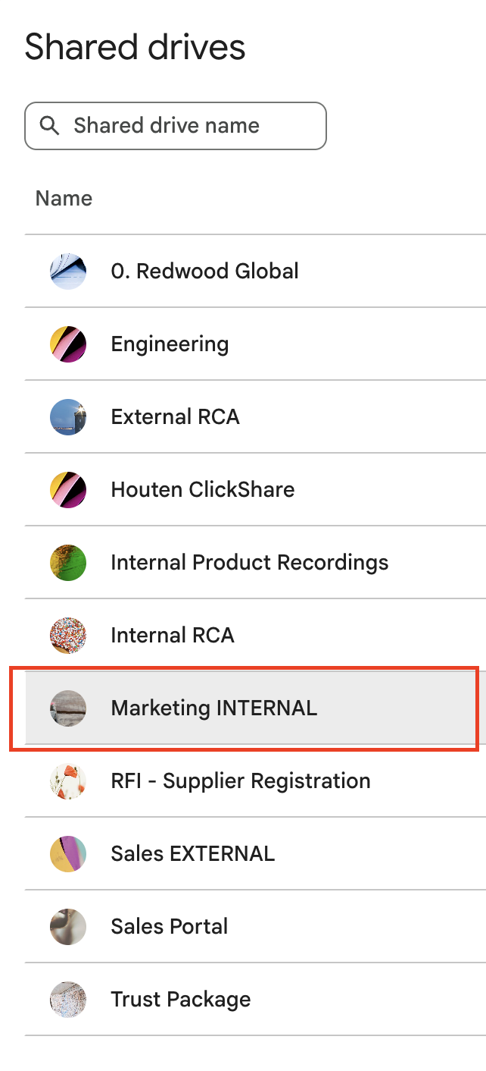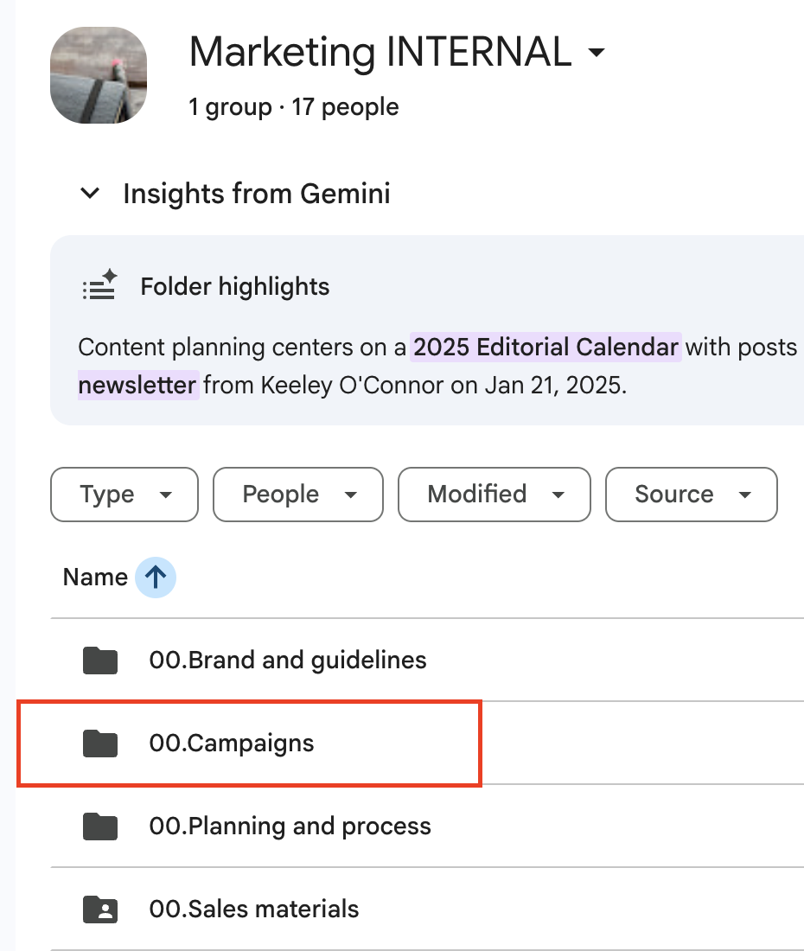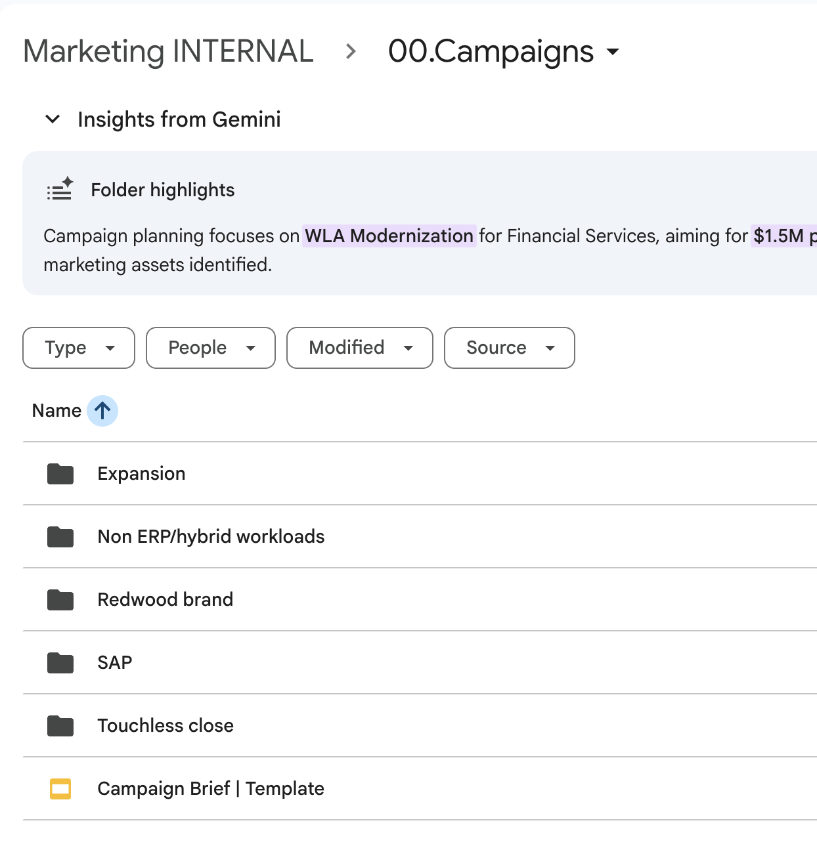
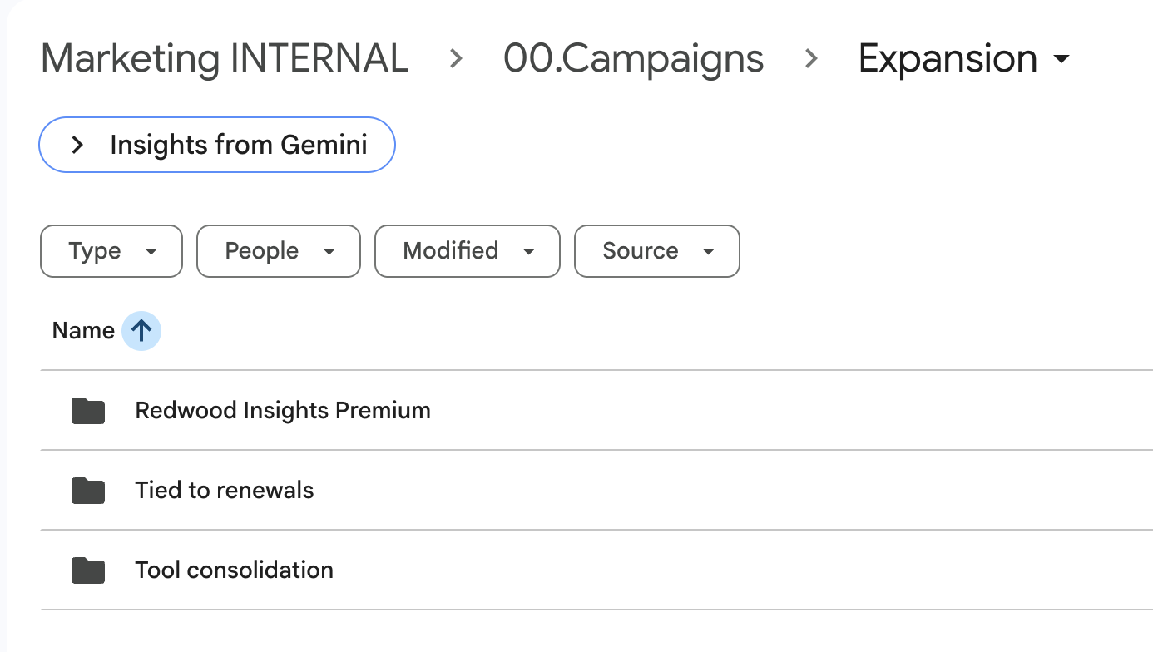

Campaign setup in Asana
Owner: Campaign manager
All campaigns must follow the standardized Asana structure below. All members of the working team and MLT should have access to the Asana campaign portfolio.
Campaign theme portfolio → matches a theme
Campaign portfolio → matches a use case or sales play
Project → matches an asset on the campaign BOM

Campaign theme portfolio
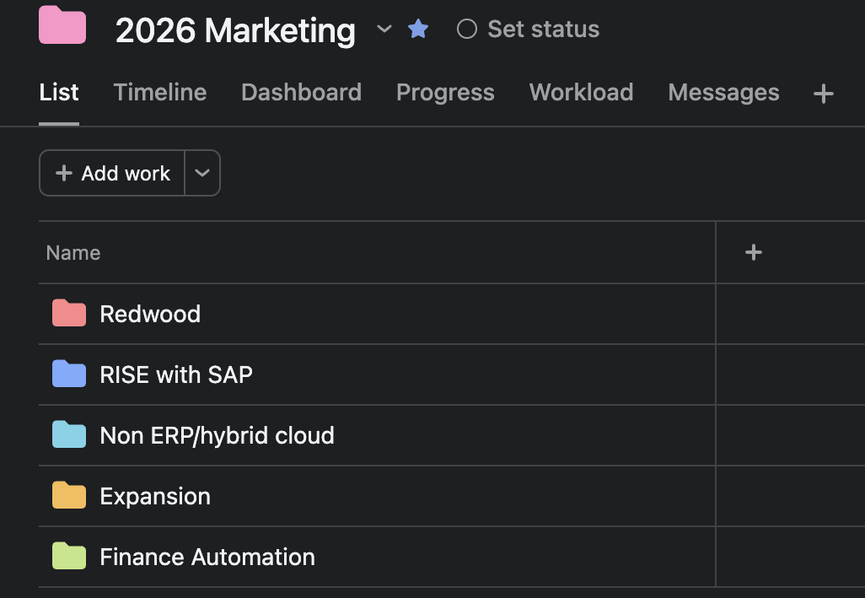
Note: The campaign theme portfolio is set up on an annual basis with modifications made quarterly as needed.

Campaign portfolio creation
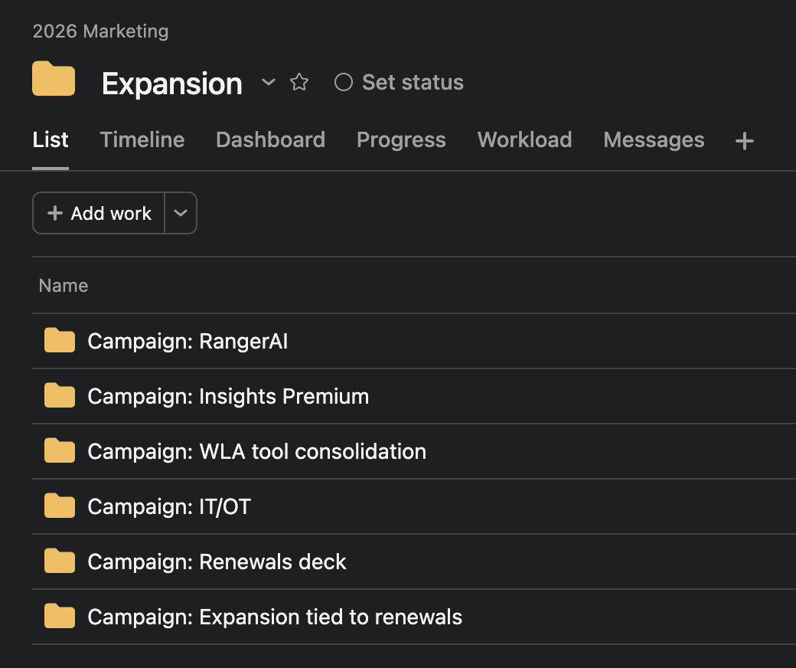
- Campaign managers create a portfolio for each campaign
- Naming convention
  - Campaign: [campaign name]
- Portfolios must be added to the appropriate campaign theme portfolio within the 2026 Marketing portfolio

Projects
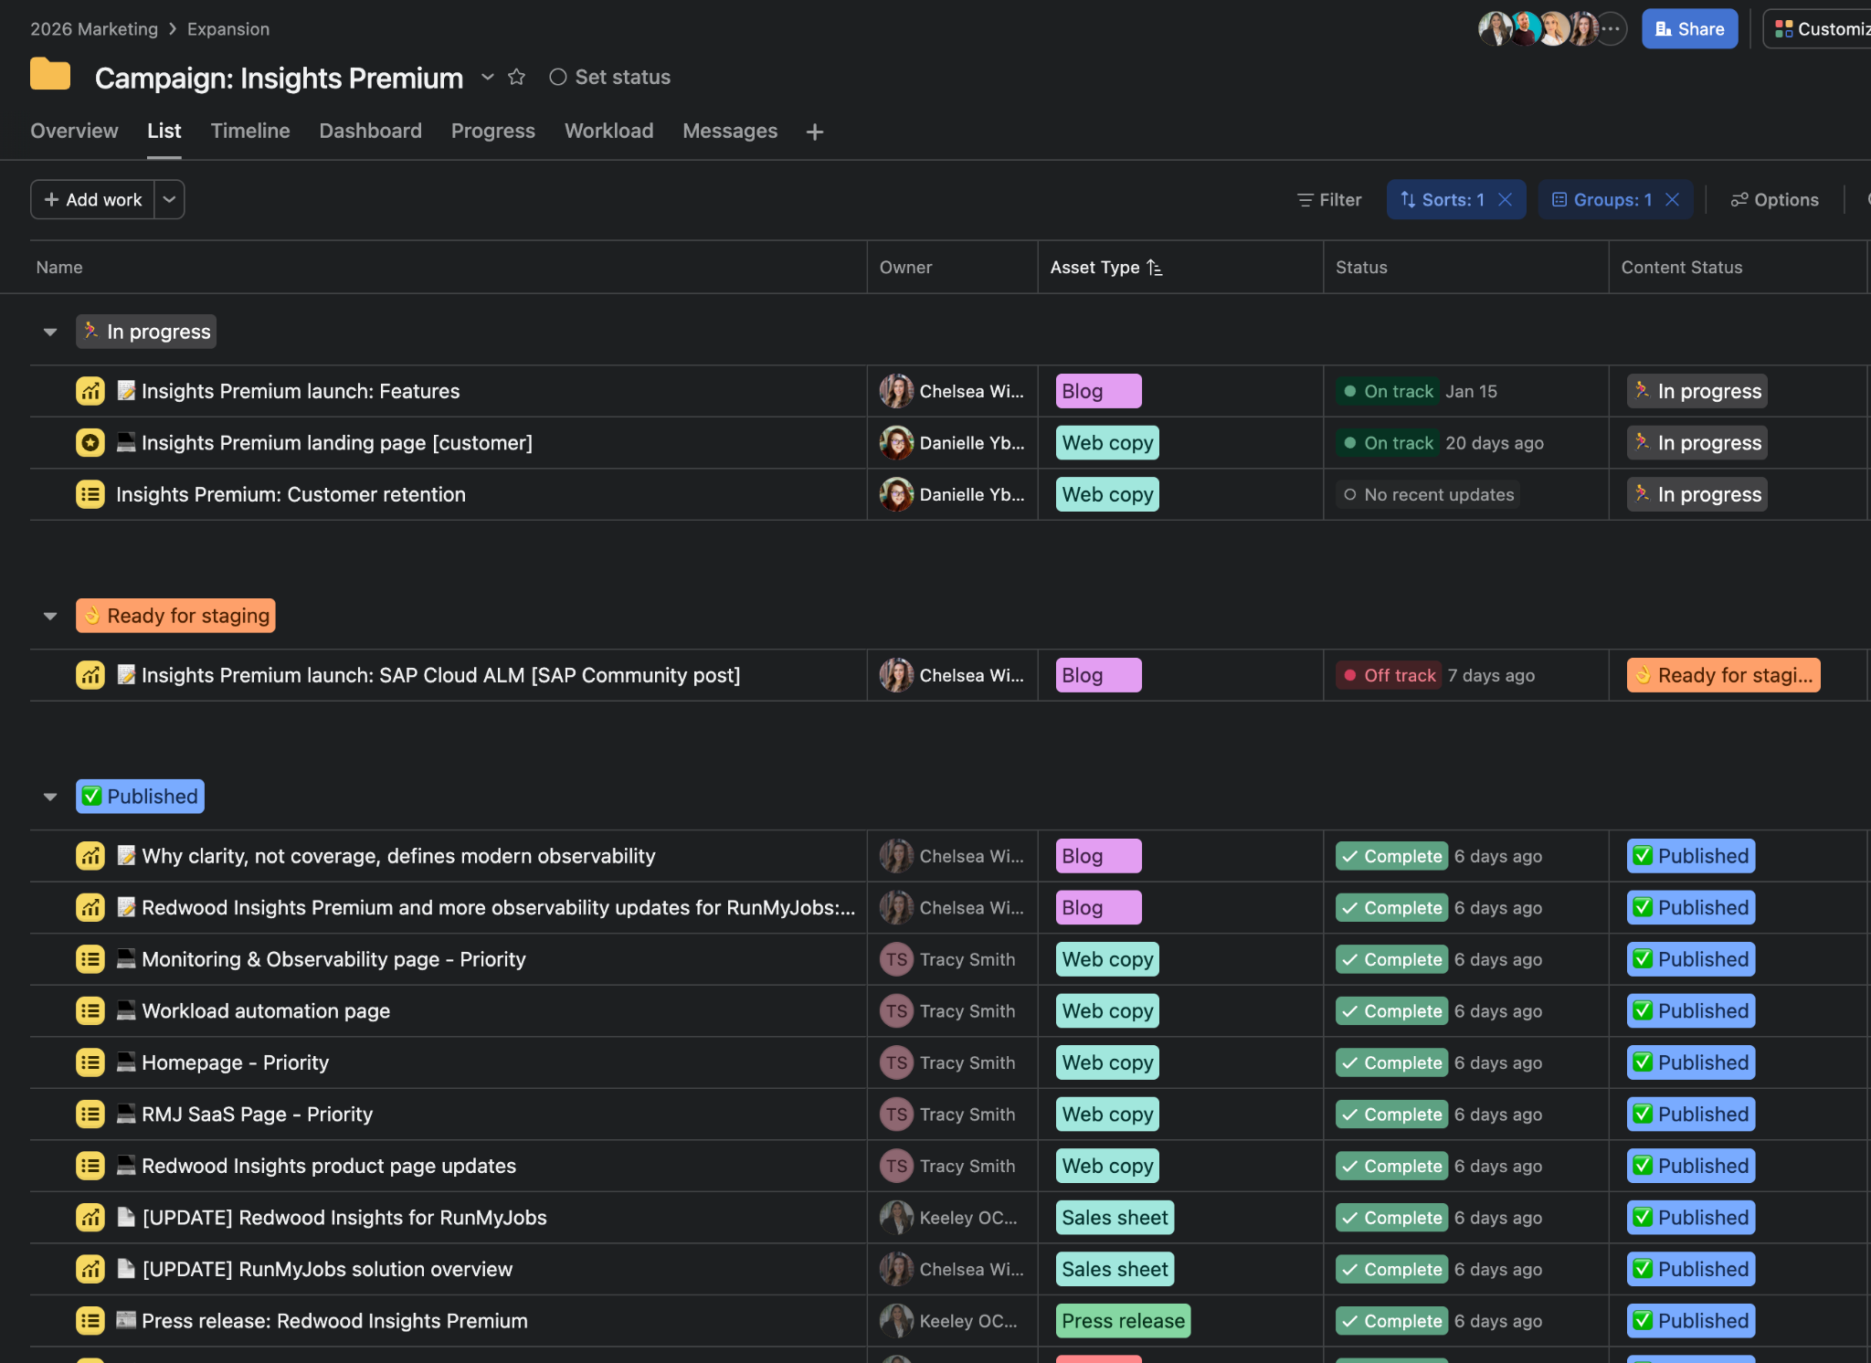
- Each functional team create their owned projects
- The Content team will add all content-related projects to the campaign portfolio
  - Other things that should be included: Pre-kickoff setup, ads, web pages, webinars, emails and weekly sprint meetings
- Campaign Managers should not create content projects themselves
- All projects will be created using approved Content team templates
Video on how to set up a project template - need to include things like turnaround time by task, dependencies, assignees, etc.

How to set up a project template
Situation A: You have frequently used task in Asana that includes other assignees and you currently duplicate this task…
- Review all tasks and subtasks to ensure they are necessary and effective.
  - Consult other assignees to ensure every task is covered, the process works for them. Confirm:
    - Dependencies
    - Turnaround times
    - Description includes what’s needed to complete this task
- Convert to project.
- Review the project and ensure this is correct.
  - Consider adding sections if it makes sense. The sections help keep the project organized and help with a board and list view and understand where a task is.
- Once your project is complete, you save it as a template.

Situation B: You do not have a task setup in Asana yet.
- List out all the tasks, subtasks and owners.
- Connect with task owners and confirm the following:
  - Tasks are correct, properly named and in order
  - Dependencies are setup and correct
  - Turnaround times
  - Description includes what’s needed to complete this task
- Create a project template in Asana using the information you put together.
Video tutorial | 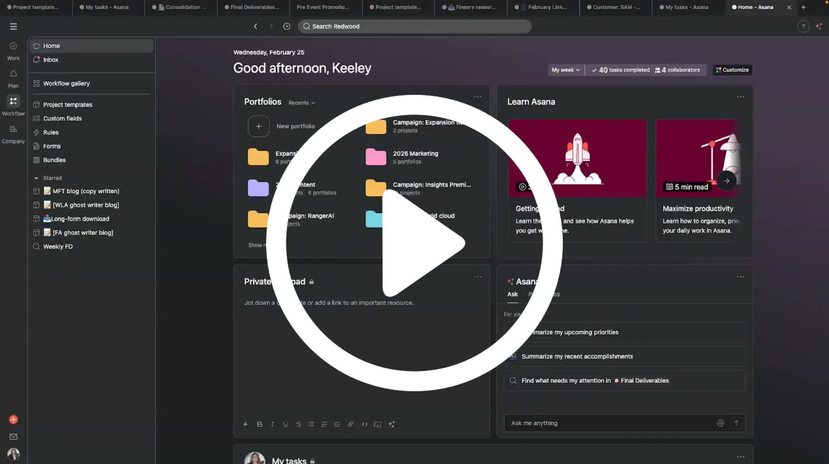

Portfolio structure
Campaigns and product launches must be organized using the following hierarchy:
2026 Marketing portfolio
└──> Campaign theme portfolio
└──> Campaign portfolio
└─-> Content projects

Working team established
Owner: Campaign manager
Identify lead team members to support key areas throughout the campaign, including:
- Product Marketing
- SEO/GEO
- Content
- Design
- Web
- Social
- Customer Marketing
- Paid
- Events
- AR
- PR

Research
Owner: Product Marketing
Asana project template: Research ⚙️
All qualitative and quantitative research informing the campaign strategy should be documented and available to the broader team. This is important to ensure messaging, targeting, content and sales enablement are grounded in real customer insights, verified ICP alignment, Sales intelligence, marketing dynamics and technical feasibility.
The Product Marketer should create a research folder for the campaign. Before kickoff, this folder must be placed in the primary campaign folder.

Market

Subject matter experts (SMEs)
Each campaign should have identified SMEs for:
- Market
- Sales
- Customer Success
- Technical/Products
All interview recordings, notes and contribution summaries should be available to the working team.
Folder: Research
└──> Folder: Internal SMEs

Redwood customers
- Customer list within the ICP
- Findings based on customer conversations
- Clari customer intelligence

Analysts
AI usage in research: Clari to analyze and gather prospect and customer intelligence based on real conversations;
Klue

Messaging and positioning 🏁
Owner: Product Marketing
Asana project template: Messaging and positioning ⚙️

A detailed messaging document should be provided to the working team at kickoff. It should include the following:
- Target market and opportunity
- ICP
- Buyer personas: title, responsibilities, DM power, pain points/challenges, goals/motivators, triggers and objections
- Market trends
- Competitor analysis: key competitors and their positioning, SWOT, differentiators, regulatory/compliance considerations, etc.
- Unique value proposition (UVP)
- Core messaging pillars
- Elevator pitch
- Taglines: different for DM vs. technical user
- Proof points (reasons to believe what we’re saying): case study, stats (must cite sources with link), timely news articles and testimonials
- Product features and capabilities
- Product benefits
- Use cases
- Integrations and compatibility
- Audience-specific language and keywords
A deck template for the messaging file can be found here. The messaging process should be a templated project in Asana to track progress. It should be added to the campaign portfolio in Asana.

AI usage in messaging: A prebuilt Gem is used to generate messaging in a standardized template; output must be thoroughly reviewed and edited by PMM to ensure specific verbiage can be used in campaign content

Slack channel
Owner: Campaign Manager

Create two Slack channel:
- Campaign channel (full working team + stakeholders)
- Purpose: Includes the entire working team and anyone who needs to stay informed
- Naming convention: ca-[campaign-name]
- Example: ca-payments-modernization
- Marketing-only campaign channel
- Purpose: Marketing team members only to have marketing-specific conversations
- Naming convention: ca-[campaign-name]-mkt
- Example: ca-payments-modernization-mkt

Pin the following in Slack channels:
- Asana campaign portfolio
- Campaign folder in the Google Drive
- Messaging documents
- Campaign brief

Keyword research and assets
Owner: SEO/GEO
⚙️Asana project template: keyword research
⚙️Asana project template: SEO solution page - new
⚙️Asana project template: SEO solution page - refresh
⚙️Asana project template: SEO product page - new
⚙️Asana project template: SEO product page - refresh
⚙️Asana project template: SEO blog post - new
⚙️Asana project template: SEO blog post - refresh
⚙️Asana project template: SEO article - new
⚙️Asana project template: SEO article - refresh

Keyword research should be conducted once messaging is complete, and does not need to be delayed until the kickoff meeting. All keyword research should live in the campaign folder on the Google Drive. Projects and tasks should be set up in Asana. Project templates exist for solution pages, blogs, articles and page refreshes.

Keyword research includes:
- Keyword analysis
- Recommendations for a solution page: layout, headers and keywords
- Recommendations for new blog and article topics
  - Blog: A unique point of view, thought-provoking or sharing something Redwood-specific
  - Articles: Informative on industry topics and more agnostic
- Recommendations for existing page refreshes
SEO/GEO recommendations should be included in the BOM. Each asset (page, post, article, etc.) should have its own Asana project. Each of these projects are owned by the appropriate member of the Web team.

Scheduling and materials for kickoff
Owner: Campaign Manager
Campaign brief template

A campaign kickoff should be scheduled as soon as the working team is identified and a timeline for messaging completion is agreed upon by the Campaign Manager and the Product Marketer. Kickoff meetings are on average 8 weeks before the campaign goes live.

The campaign brief deck should include:
- Campaign name
- Working team
- Links to the Asana campaign portfolio, Google Drive folder, Slack channel and appropriate messaging documents
- Target launch date
- Objective
- Audience
- Key messaging
- Channels and tactics
- Deliverables (BOM) with owners, due dates and placements
- Key metrics: leading and lagging indicators
NOTE: Timelines assume final campaign messaging is provided before work begins and reviews are completed on time. Delays in reviews may impact launch dates.

Turnaround time by deliverable for planning
Deliverable | Average turnaround time after receiving messaging/content
New product or solution page | 4 weeks
Refresh to a product or solution page | 2 weeks
SEO-driven blog posts or articles | 2 weeks
Press release | 3 weeks
Thought leadership blog posts | 3 weeks
Sales sheet | 2 weeks
Bylined articles | 3 weeks
Research and insights report | 6-8 weeks
Long-form educational content (eBook, playbook, whitepaper) | 5 weeks
Ad campaign | 3 weeks
BDR sequence | 3-4 weeks
Email campaigns | 2-3 weeks
Non-demo video (explainers, brand, thought leadership, customer story) | 3 weeks
Demo video | 1 week if demo
Connector page: new or updated | 2 weeks
Case study | 1 week after customer interview for copy; approval timeline is unknown

🏁Campaign kickoff meeting
Asset creation begins only after a formal campaign kickoff with all the required inputs completed.

Kickoff expectations
- Kickoff occurs once campaign goals and scope are defined and target launch date is confirmed
- Campaign Manager owns the kickoff meeting
- Final, fully-approved messaging will be provided
- A high-level technical knowledge will be provided, if applicable, to align Marketing on product changes
- The complete BOM (deliverables) will be provided with timelines
- A meeting cadence will be established; all meetings need to have an agenda and follow meeting guidelines; click here for meeting best practices
Requests missing these inputs will be paused until they are complete.

Phase 2: Campaign development (post-kickoff)

Adding deliverables to Asana
Owner: Each project owner

Following the campaign kickoff meeting, each item in the BOM needs to be added to the campaign portfolio folder in Asana as a project within 48 hours. Each campaign project should have the campaign in the campaign field.
- Custom fields need to be completed, including:
  - Asset type
  - Publish date
  - Campaign name
  - Campaign theme
  - Brand
  - Drive folder link
  - Deliverable link
This ensures accurate tracking, reporting and prioritization.
Video tutorial
All functions should have established templates for each deliverable that they own. The project template needs to include all tasks, subtasks, assignees, turnaround times and dependencies. This requires cross-functional collaboration to ensure all assignees understand and agree with their roles in the project.

Here is a breakdown of who owns the deliverable and corresponding Asana templates, and how each of these deliverables start to be developed. Every item on this list might not be applicable to all campaigns.

Deliverable and Asana template | Owner | Who kicks off the deliverable/project | What action kicks off
Analyst meeting | Creative and Comms | Campaign Manager | Submits inquiry questions
Bylined articles | Creative and Comms | Kickoff: Comms | Works with PR
Long-form: research report, whitepaper, eBook | Creative and Comms | Kickoff: Content | Provides title and outline to Campaign Manager
Press release | Creative and Comms | Campaign Manager | Provides press release messaging template
Sales sheet | Creative and Comms | Campaign Manager | Provides sheet copy  New  Update
Social media campaign | Creative and Comms | Kickoff: Comms | Plans campaign around assets
Thought leadership blog post  WLA / FA / MFT | Creative and Comms | Kickoff: Content | Provides titles and outlines to Campaign Manager
Non-demo video | Creative and Comms | Campaign Manager | Schedules a call with Mark Burbery and Stephani Fitzsimmons
SEO article | SEO/GEO | Pre-kickoff: Product Marketing | Provides messaging
SEO blog post | SEO/GEO | Pre-kickoff: Product Marketing | Provides messaging
SEO page refresh | SEO/GEO | Pre-kickoff: Product Marketing | Provides messaging
New solution/product page | SEO/GEO | Pre-kickoff: Product Marketing | Provides messaging
Ad campaigns | Paid | Kickoff: Campaign Manager | Creates campaign
Email campaigns | Campaign Manager | Kickoff: Campaign Manager | Creates email plan (frequency) and copy
Newsletter | Campaign Manager | Kickoff: Customer Marketing | Created email copy
Landing page | Campaign Manager | Kickoff: Campaign Manager | Creates copy
Webinar | Campaign Manager | Kickoff: Campaign Manager | Creates plan (ideation, hosts, etc.)
Connector web page | SEO/GEO | Kickoff: Product Marketer | Provides connector copy
Storylane/demo video | Product Marketing | Kickoff: Product Marketer | Provides Storylane demo video
Sales enablement deck | Product Marketing | Kickoff: Product Marketer | Creates sales enablement deck
Sales slides | Product Marketing | Kickoff: Product Marketing | Provides sales slide content
Case study/testimonial | Customer Marketing | Kickoff: Campaign Manager | Provides scope and direction
Customer emails (standalone or newlsetter) | Customer Marketing | Kickoff: Campaign Manager | Provides messaging
Customer webinar | Customer Marketing | Kickoff: Campaign Manager | Provides messaging
Customer portal/in-product comms | Customer Marketing | Kickoff: Campaign Manager | Provides messaging
Reporting dashboard | MarOps | Kickoff: MarOps | Sets up dashboard and obtains asset and performance links
Internal communications | Campaign Manager | Kickoff: Campaign Manager

Adding folders to the Google folder
Owner: Each project owner

Each Asana project should have a corresponding folder in the primary campaign folder in Google Drive. This is the responsibility of the project owner. If a function would like the file to live in another folder as well, a shortcut should be used.




Reporting
Metrics must be established and assigned owners prior to the kickoff meeting.
The Campaign Manager is responsible for working with the Reporting team to set up a dashboard access/filtering for each campaign.
Working team members are responsible for ensuring performance metrics are provided if there is no automated system in place to capture them.
Reporting should include:
Product adoption

Channel performance

Web
- Campaign-attributed sessions
- Landing page conversion rate
- Form fills
- Individual page performance, including engagement rate/time on page

Email
- Delivery rate
- Open rate
- Click-through rate (CTR)
- Conversion rate

Paid media (search, social, display)
- Impressions
- CTR
- CPC / CPL
- Conversion rate

Organic social
- Reach
- Engagement rate
- Click-throughs
- Pipeline attribution

PR
- Media placements
- Estimated reach
- Referral traffic

Funnel impact
- New contacts created
- Opportunities created
- Conversion rates in the sales stages
- Lead source attribution
- Pipeline generated
- Average deal size
- Win rate
- Cost per opportunity
- Cost per pipeline dollar
- Revenue
- Closed or current deals in the sales cycle

Product adoption - applicable to product launches

Communications and channels

Status updates
- Asana
  - Projects should be set up with dependencies so that task owners are automatically informed when their dependent tasks can be completed
  - Project owners should use Asana’s status updates feature to inform stakeholders of any changes in project status
  - Each assignee should use comments on their given tasks to provide details about any delays or blockers
- Slack
  - Campaign Managers should use the dedicated Slack channel to communicate any changes in launch dates, scope of campaign or other key updates
  - Additional requests or questions from the team should only be shared in the dedicated campaign channel; ad hoc group messages should not be created
- Meetings
  - Campaign Managers should check on the status of tasks via Asana prior to the status meeting
  - Campaign Managers should provide an agenda for each status meeting and a summary of outstanding and upcoming tasks after the meeting

Feedback and approvals during asset creation
Feedback is crucial to capture and implement during the asset creation process. All review tasks should be included in project templates, and all relevant documents should be linked in the tasks for quick access and clarity. Reviewers should be aware that this step is a barrier to advancing asset creation, so it is important to provide feedback in a concise, timely manner.
If a review is assigned to one person within a function, such as Product Marketing, it is that person’s responsibility to gather and implement all feedback on behalf of their team within the due date.
When reviewing in Google Docs or Slides…
- Use “suggesting” mode
- Leave specific comments or edits directly in the document
- Do not create a new document — use the file shared with you to review
After you have finished reviewing the Google file…
- Mark the review task complete in Asana
- Leave a summary comment such as “Left a few suggestions mainly around X” or “Looks good, no changes”
- Tag relevant stakeholders
If you do not complete your review task on time, the project will not move forward.

Meeting cadence
- Kickoff meeting - generally 8 weeks before the campaign is live
- Weekly or biweekly status meeting - the status of all campaign deliverables should be available and updated in the campaign portfolio in Asana
  - An agenda for this meeting needs to be included at least 48 hours prior with detailed discussion points
  - The Campaign Manager determines who should be in this meeting on a weekly/biweekly basis
- Go live meeting 1 week before launch
- Post-mortem a week after launch - a survey should be sent within 48 hours of launch to capture feedback; the post-mortem should present key takeaways, themes and action items
- Campaign performance tracking meeting - Taking place a on 30, 60 and 90-day cadence, the meeting will review campaign performance with the entire working team welcome to join and understand how their work is impacting the business.

Resources

Asana learning path

Course | Objective | Time
Getting started with Asana | This recorded training covers the basics of task management including how to create projects and tasks in Asana. | 45 mins
Asana foundations course | Get a clear view of your work, organize projects effectively and collaborate across your team on Asana's collaborative work platform. | 1-2 hours
Asana campaign management | You’ll learn essential principles of campaign management, how to confidently organize, launch and optimize your work, while using core Asana features to build structure, increase visibility and strengthen collaboration. Along the way, you’ll deepen your ability to track performance, scale your process, and leverage automation and AI to drive results. | 1-2 hours

Redwood Asana tutorial videos

Video | Objective | Time
Creating a project template | How to create a project template from scratch or from an existing project | 17 mins
Setting up projects | Adding your project to the correct portfolio and updating the project fields | 3 mins

For questions or support:
- Contact the Content Marketing Manager (Keeley OConnor) for process questions
- Refer to Asana Academy for tool guidance
- Use this playbook as the source of truth for campaign to content workflows

